FlyWeight Design Pattern
Monday, June 29, 2020
3:30 PM
享元模式

Intent: Each composite refers to the same leaf instance
- Support a very large numbers of fine-grained objects.
Requirement: The stake information of each object can be retrieved on demand.

Benefits:

- Allows you to create a huge number of virtual objects without having to explicitly instantiate every single one.
- The pattern reduces memory footprint and speeds up your code
- The pattern simplifies your code
- You can create very elegant code by combining the flyweight pattern with the Enumerator or Visitor Pattern

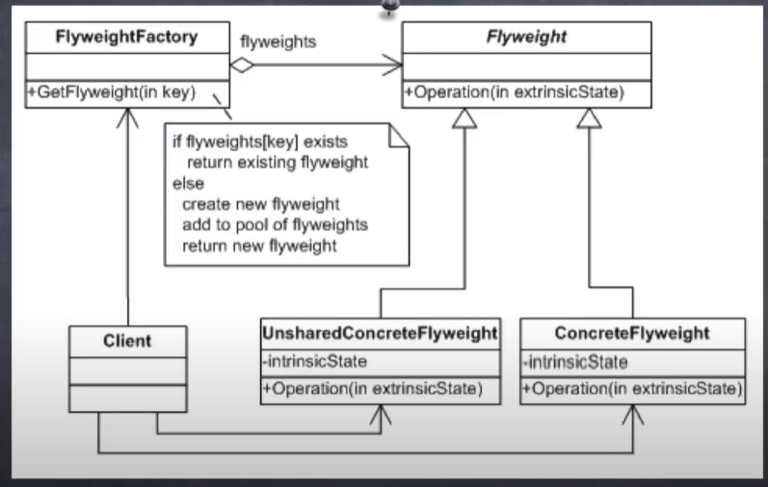

CheckList:
- Make sure you need to support a very large numbers of fine-grained objects and that the extrinsic stake can be retrieved quickly and on demand. T: Like image position of image
- Split the object stake into shareable intrinsic stake and non-shareable extrinsic stake. T:Intrinsic - Image Filename Extrinsic-Image display position.
- Remove the extrinsic stake from the object and add it to the calling argument list of all affected methods.
- Create a factory that can cache and reuse existing class instances.
- Change the client to use the factory to request objects
- Change the client to look up extrinsic stake and provide it to all methods

Final Comments:
- The flyweight pattern requires you to look up the extrinsic stake on demand, so you need to have this data available in some kind of fast medium.
- If There is a performance hit when accessing extrinsic state you will experience this hit every time you call any method on the flyweight objects.
Add:
Adaptability:
一个应用程序使用了大量的对象。由此造成了很大内存开销，所以应该考虑享元模式。
对象的大多数状态都可变为外部状态。
如果删除对象的外部状态，那么可以用相对较少的共享对象取代很多组对象。
- 一个对象在一个场景被使用后， 可以删其外部状态，继续放入池中使用。
应用程序不依赖于对象标识。由于Flyweight对象可以被共享，对于概念上明显有别的对象，标识测试将返回真值。

个人理解： 内部特征类似于固定不变的key去索引享元对象。
只有在需要大量实例时才建议使用，因为该模式需要额外构建一个表来存储享元实例。
场景举例：
同一时刻最多用到5个具有不同外部特征的对象，且用完后不会继续使用，所以可以抹掉其外部特征。 但是整个流程中要用到10000个这种不同外部特征的对象。那么我们只需要建5个对象并保存在Dictionary中，并在需要使用时赋予外部特征使用，使用完之后抹掉外部特征放入Dictionary中。 这样能够大大减少存储消耗。

